Kyu individual poules

Poule 1
Dennis
Tim
Erick

Poule 2
Jerry
Aran
Inne

Poule 3
Assi
Harry

Dan individual poules

Poule 1
Martin
Tjalling
Willem

Poule 2
Daan
Harmen
Mark

Poule 3
Pieter
Jan Paul
John
Wim

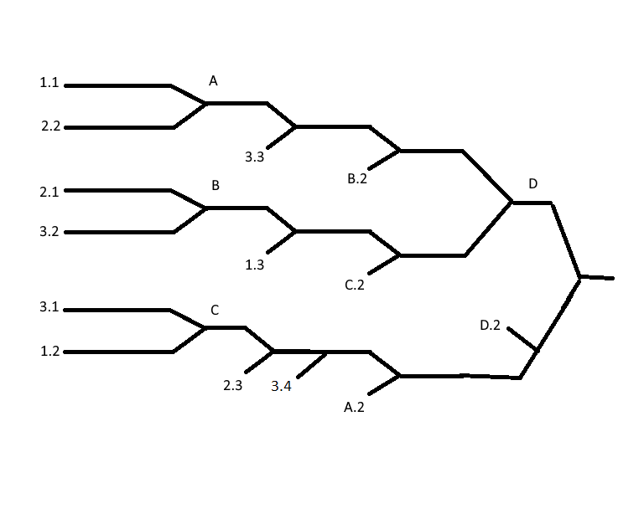

Teams

Team 1
Inne
Jerry
Harmen

Team 2
Harry
Tjalling
Jan Paul

Team 3
Dennis
John
Daan

Team 4
Assi
Mark
Pieter

Team 5
Erick
Willem
Martin

Team 6
Aran
Wim
Elmar

Teams poules

Poule 1
Team 1
Team 2
Team 3

Poule 2
Team 4
Team 5
Team 6

